Name: |  | ____SOLUTIONS_______________________________________ |  |  |  | Date:__________
 |  | Subject: METHODS MAT  Investigation 3, 2015  Topic – Applications of Differentiation  Take home component
Important Information:
Although the take-home component is not worth any marks, it is essential in preparation for the in-class component. Knowledge and skills gained will be extended in the in-class validation component. This in-class validation will be completed under test conditions on the day in which this take-home component is due. The take-home component may be used when completing the in-class component. Contact may be made to parent(s) if the take-home component is not available for submission (at the start of the lesson).

Date out: |  |  | Week ____ Date __________ | Date Due: | Week ____ Date _________
Take home component weighting: |  |  | 0% of the year | In-class component weighting: | 5% of the year.
AIM: The concepts and skills covered in this investigation consists of activities which allow students to calculate derivatives of polynomials and to solve optimisation problems arising in a variety of contexts involving polynomials on finite interval domains

Problem 1

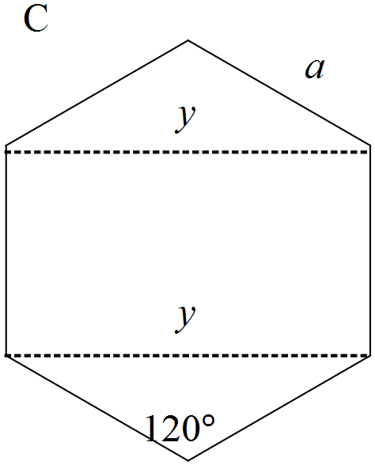A: Square
Length = 2 m, Area = 4 m²

B: Equilateral triangle
Length = m, Area =
C: Regular hexagon
Length of side = a = m
D: Circle
Radius =
Area =
In order of increasing magnitude the shapes are triangle, quadrilateral, hexagon, circle. The greater the number of sides the greater the area (assuming the circle has infinite number of sides)
A pentagon with a perimeter of 8 m would have an area between 4 and 4.619 m²

Problem 2
Solution

A: Rectangular prism
(a)
(b)
(c) metres
(d) metres
(e) m³

B: Triangular prism
(b)
(c)
(d) metres
(e) metres
(f) m³

C: Cylindrical garden bed
(a)
(b)
(c)
(d) Maximum volume =

Shape | Restriction | Dimensions for maximum volume (m) | Maximum volume  (m³)
Rectangular prism |  |  | 2.31
Triangular prism |  |  | 2.31
Cylinder |  |  | 14.544

Comment

- There is no clear indication from these results that a particular shape will produce the maximum volume as two shapes have the same volume. There is not a consistent restriction (variables not controlled) for a conclusion to be valid.
- Another method to locate a maximum value for volume is to plot the volume function (when reduced to one variable) and find the local maximum on the graph. Calculus offers a more accurate and quicker way to locate the maximum value.

